Dokumentasi Challenge Q2 – Software

* kubectl get nodes

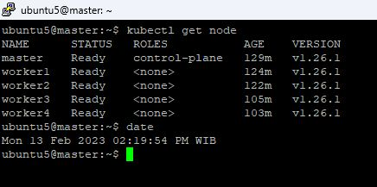

* kubectl describe
* kubectl get pod -A
* kubectl get svc -A
* kubectl get secret
* kubectl get configmap
* kubectl pv
* kubectl get pvc